Individual Submission (Page 3 and 4 only)
Group #3:
Lab 2.1 Answer
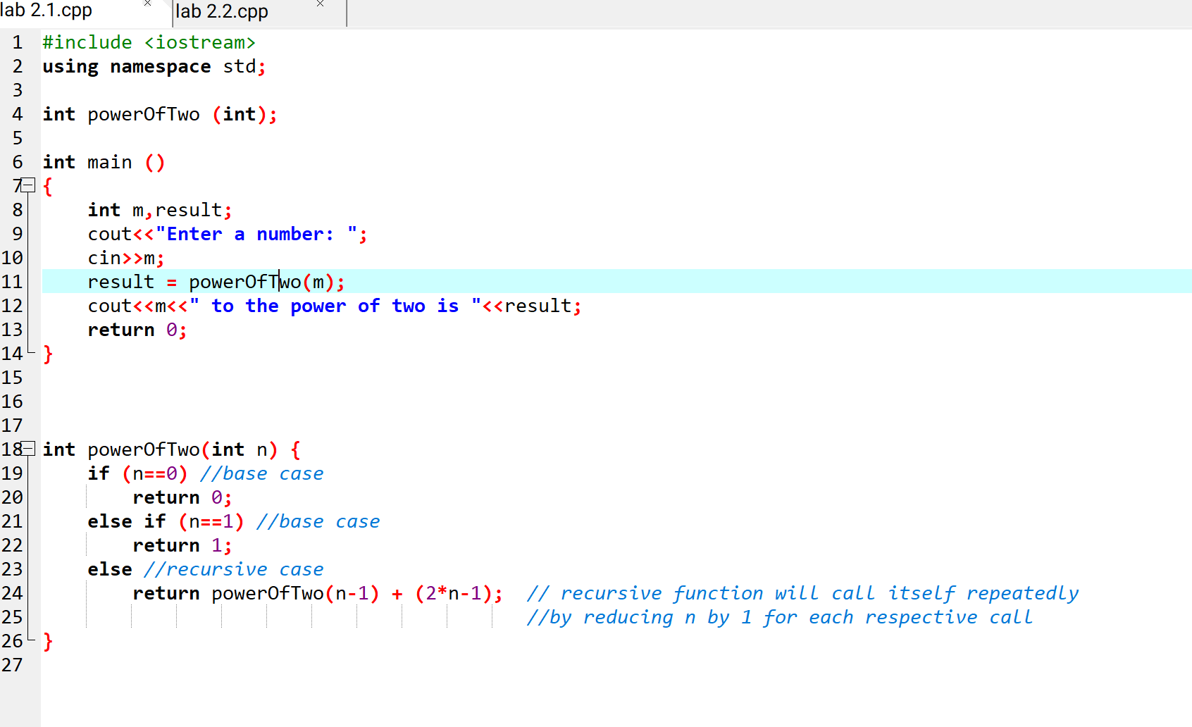

Lab 2.2 Answer
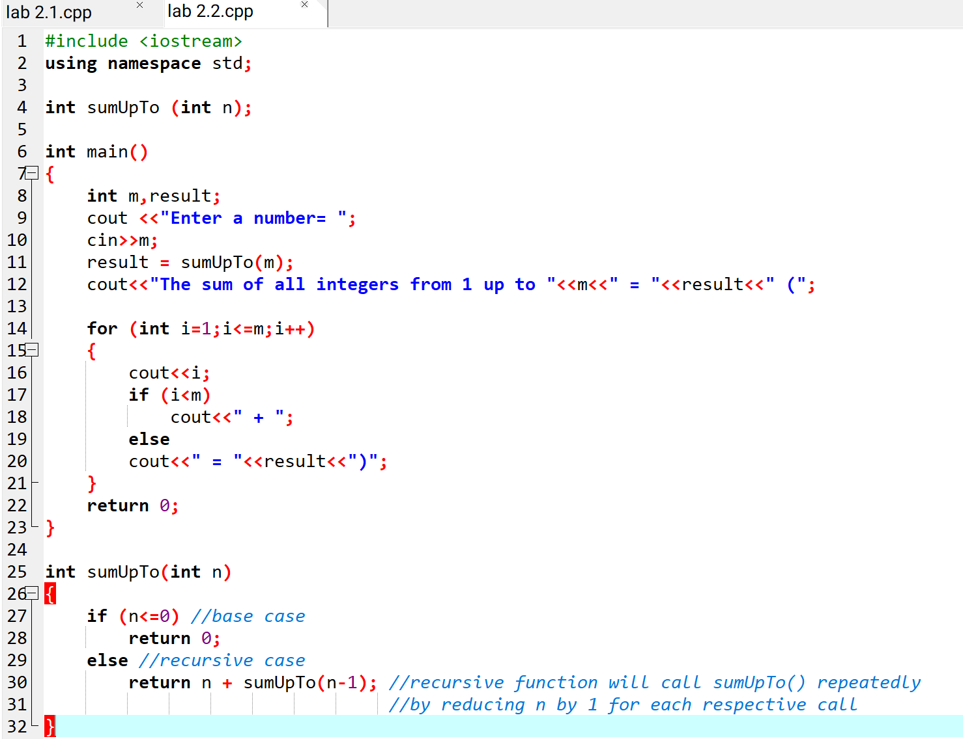

Total Score: /15 (Each student rates themselves and each of their peers individually)
Submission: Each student submits an individual assessment of their own contributions and those of their group members based on contributions and teamwork.

Evaluator/Criteria | Technical Skills(/4) | Idea Contribution(/4) | Engagement & Seriousness (/4) | Collaboration & Team Spirit (/3) | Total(/15)
Evelyn Goh  (Self-evaluation) | 4 | 4 | 4 | 3 | 15
Lim Yu Han | 4 | 4 | 4 | 3 | 15
Pravinraj | 4 | 4 | 4 | 3 | 15
Anis Safiyya | 4 | 4 | 4 | 3 | 15

